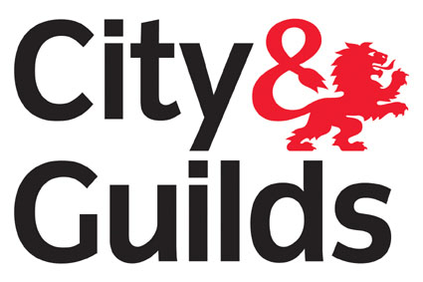

Level 2 Award in Health and Safety in the Workplace
Qualification No: 4065-12 Accreditation No: 501/2252/6
Who is this qualification for?

The Award is ideal for any organisation that wishes to adopt a standard approach to Health and Safety in the workplace and ensure the basic legislative requirements regarding appropriate precautions are met by employees, work placement students or apprentices. A single unit qualification was aimed at new staff, or existing staff who need health and safety training.
Qualification Structure

To achieve the Level 2 Award in Health and Safety in the Workplace, learners must achieve 1 credit from the mandatory units
Guided Learning Hours: 10
Candidates must finish their assessment within 6 months.

Unit No | Unit Title | Credit Value
Mandatory
201 | Health and Safety in the workplace | 1

Test Duration: 1 hour
You will be questioned on the following:

Unit No | Outcome | No of Questions
Mandatory
201 | 1. Understand roles and responsibilities for health, safety and welfare in the workplace | 6
 | 2. Understand how risk assessments contribute to health and safety | 4
 | 3. Understand how to identify and control the risks from common workplace hazards | 5
 | 4. Know the procedures for responding to accidents and incidents in the workplace | 5

What does this qualification cover?

This qualification was developed to provide candidates with a general qualification in Health and Safety for the Workplace. The development was prompted by a demand for a generic health and safety qualification at Level 2, rather than qualifications designed for use in specific sectors, as this would have the widest appeal to employers.

Entry requirements?

There are no formal entry requirements or age restrictions for candidates undertaking this qualification.

Progression routes?

A Certificate in Health and Safety in the Workplace provides more knowledge of particular aspects of Health and Safety. It would allow you to progress to the following qualification:
- Level 3 NVQ Certificate in Occupational Health and Safety (QCF)
- Level 5 NVQ Diploma in Occupational Health and Safety Practice (QCF)

Safety Advisory Services Ltd is an Approved City and Guilds Provider, Centre No: 722250.

Find us at: 1 Cranham Court, Arden Square, Crewe Business Park, Crewe, CW1 6HA (UK).

Call on: +44 (0)1270 584552
Email us: services@sas-ltd.co.uk
Web: www.sas-ltd.co.uk

Ref: /tmp/in/input.doc

